**Team Assessment**

**CARE International in Jordan**

**Initiative Title: “BADERI!” Unleashing the Entrepreneurial Potential of Women and Enhancing Access to Economic Empowerment Opportunities for Jordanian and Refugee Women**

**May 2018**

1. **Team members:**
2. **Back ground on team members:**

Currently, the team is made up of 3 members:

Sawsan Mohammad Sa’ada: Director of the Sustainable Development program in CARE International in Jordan and the SXD team captain, CV attached

Firas Izzat: Program Quality Director in CARE International in Jordan and the SXD co-captain, CV attached

Irina Karic, M&E manager in CARE International in Jordan and team member in the SXD team, CV attached

And there’s a possibility of adding in more members as we advance in implementation and the need for more members arises. The SXD team will be updated on this.

1. **Role of team members:**

Sawsan, I, was involved in designing and managing projects of WEE and WV for years and she’s the manager of the program under which the proposed activities for SXD will be implemented. So she will be overseeing, and involved at some points of time, the design, planning and direct implementation of the activities and providing technical support especially on aspects like gender transformative programing, engaging men and boys and partnership with and engagement of the local communities. Firas and Irina are both from the PQ program and have experience in monitoring and evaluating WEE projects/program. They will be following up the implementation, target reaching and quality such as documentation, reporting, prevention of sexual exploitation and donor’s requirements. The three of us will be work jointly, as usual, to multiply the impact of the proposed activities and scale up the numbers, geographical areas and ensure longer-term impact.

1. **Accommodation for participants:**

No requirements at the time being;

1. **Profile:**

**Pictures of the activities:**

Please note that these picture are from the 1st phase of the Baderi campaign and I will be sharing pics form the current campaign as soon as we start with the regional tours for the selected women entrepreneurs, as well as the 2 other activities: the E-wallet and work opportunities for women in Azraq camp.

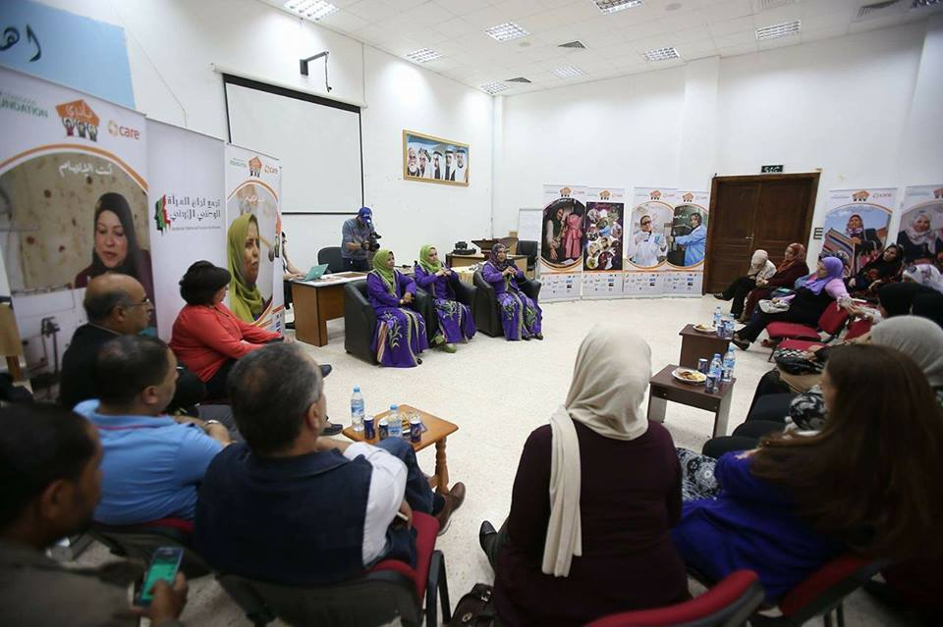

Figure the regional tours for the entrepreneur women where they meet with community members, share their success stories and spread awareness on women’s' economic empowerment .

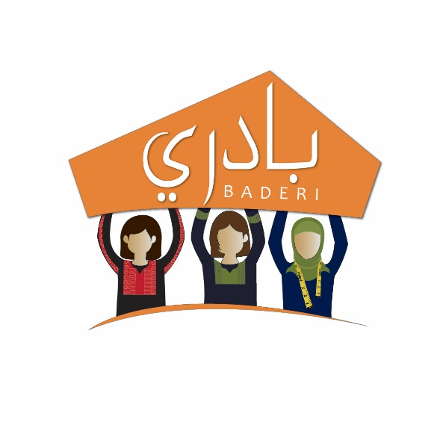

Figure the logo of the campaign

**Project Objective:**

This project seeks to **bring about economic inclusiveness for women both Jordanian and refugee**. It will initiate changes in community members’ knowledge, attitude and behavior to address the issue of women’s low economic participation in Jordan via the following: 1. Involvement of successful women entrepreneurs through nationwide tours, including Azraq refugee camp, and, once scaled up, across the region, who will share their struggles and successes as women entrepreneurs with other women, men and youth, to advocate for WEE and greater involvement in the workforce; 2. Increased number of community members, particularly women, participating at existing CARE’s Satellite technical production units in Azraq camp, by encouraging women and enhancing their access to employment opportunities inside and outside Azraq camp, via training in technical and manufacturing processes and soft skills, building on the existing collaboration between CARE, ILO and UNHCR to establish the employment center in Azraq; 3. Utilization of E-Wallet, in cooperation with Central Bank, a banking tool that will ensure women’s access to financial resources and will promote financial inclusion and independence for women participating in the above-mentioned components.

**Project Description:**

The first component builds on BADERI campaign, which started two years ago, whose emphasis on women’s active participation and leadership in the labor market, has helped build capacity and raise awareness about WEE. This project will scale up its reach and impact by targeting the most vulnerable in poor and remote areas of Jordan, and will also involve men and youth, to further expand women’s economic participation and awareness. This initiative seeks greater political involvement of the GoJ, the Ministry of Social Development, respective Municipality Councils and of individuals active in domains of economic development and women’s rights.

As the only opportunity to work in Azraq camp is present through the Incentive Based Volunteering scheme, the second component will address a dearth of employment by enabling camp residents to hone old and learn new skills and gain employment at technical production units, supported by strategic private sector donors (H&M and GAP). The provision of jobs in the garment industry corresponds with the demand in this sector, the camp residents’ interests and with the GoJ's Response Plan. This project will build on the training being offered to program workers and supervisors in the camp on technical aspects and soft skills. Selected role-models will discuss with refugee members the challenges and opportunities via several campaigns inside Azraq camp. CARE is addressing key work barriers through the existing childcare facilities inside the technical/Satellite training unit camp.

With the same utility as a credit or debit card, E-wallet is a type of pre-paid account, to which beneficiaries, particularly refugees with no bank account, can store money for future online transactions. The selected women entrepreneurs will initially pilot the use of E-Wallet and similar technologies, then will later inform others of its benefits. As women are inspired to take leadership roles in household finances, E-Wallet can help close the gender gap, enhance participants’ access, resilience and control over finances and will specifically address the refugees’ lack of access to a bank account.

**Progress made to date:**

* Selection criteria for the selection of the entrepreneur women for the regional campaign
* Agreement signed with the Central Bank of Jordan on the use of the E-wallet
* Discussions with 2 garment factories in the QIZ close to Azarq Camp to explore employment opportunities for Syrian women from the camp in addition to the technical training that was provided recently to the women on sewing.

**Accelerator Outcomes:**

No outcomes to date;

**Moving Forward:**

- entrepreneur women to be selected and start of training program on community mobilization, gender equlity

- pilot of the E-wallet with local community and refugees, targeting also women, and later the selected entrepreneur women to be trained on the use of the wallet and introduce it to their audience

- continue discussions with garment factories in the QIZs to agree on suitable work conditions for the women from the camp. In the same time, work on changing the attitude of the women, and their families, in the camp on women’s work and on promoting the idea of decent, sustainable livelihoods for women.

**III. Innovation:**

**Background Documents:**

Attached are the final report on the previous Baderi campaign.

**Start of Process of Scaling up:**

Not yet;

**Scale up Five Years from Now:**

We envisage more local and refugee communities in Jordan appreciating and supporting women’s economic participation and more women believing in themselves, in their entrepreneurship and daring to start/expand their own income generating activities and have control over income.

We also want to see women and other marginalized groups such as refugees have access to financial resources through technology (the E-wallet, for instance).

We’re eager to see that women in the refugee camps, in spite of the limitation on opportunities there, have acquired skills and access to dignifying, sustainable livelihoods.

**Barriers to Scale up:**

The main 2 barriers so far are: people’s attitudes and the rooted image on women’s role in the community and around typical gender roles, and the second is on mediating between the private sector’s for-profit mindset and activities and our program’s, as a non-profit organization, for the purpose of promoting women’s work and empowerment.

**Priority Learning or set of Skills for the Team:**

Attitude change activities, negotiating with stake holders with different mindset and objectives such as the private sector, innovation in economic inclusiveness for women and refugees;

**What Support is Needed from a Mentor?**

Same as the above answer;

**Why Would a consultant be Needed?**

For: 1. the community mobilization training for the selected entrepreneur women for the Baderi campaign; 2. for the media coverage for the campaign to maximize the impact of the campaign; 3. the sensitization sessions/activities with families, especially men and male youth, in the camp to make an attitude change around women’s economic empowerment;